Unit-5: Random Numbers
Introduction to Random Numbers:
Random numbers are samples drawn from a uniformly distributed random variable between some satisfied intervals they have equal probability of occurrence.

Hence, the term suggests, a random number is a number chosen by chance -- i.e., randomly, from a set of numbers. All the numbers in a specified distribution have equal probability of being chosen randomly.

A random number occurs in a specified distribution only when two conditions are met: The values are uniformly distributed over a defined interval or set, and it is impossible to predict future values based on past or present ones.

Random numbers are characterized by the fact that their value cannot be predicted. Or, in other words, if one constructs a sequence of random numbers, the probability distribution of the following random numbers has to be completely independent of all the other generated numbers.

Random numbers are a necessary basic ingredient in the simulation of almost all discrete systems. Most computer languages have a subroutine, object, or function that will generate a random number. Similarly, simulation languages generate random numbers that are used to generate event times and other random variables.

Random Number Tables
A table of numbers generated in an unpredictable, haphazard (hit-or-miss) that are uniformly distributed within certain interval are called random number table.
The random number in random number table exactly obeys (follow) two random number properties:
- Uniformity
- Independence
So, random number generated to form of table also called true random numbers.
Table of random numbers are used to create a Radom sample. A random number table is also called random sample table. There are many physical devices or process that can be used to generate a sequence of uniformly distributed random numbers i.e. true random numbers.

Properties of Random Numbers:
- A sequence of random numbers, 𝑅1, 𝑅2, 𝑅3,…..Rn must have two important properties:
- Uniformity, i.e. they are equally probable/distributed every where
- Independence, i.e. the current value of a random variable has no relation with the previous values
- Each random number R_{t} is an independent sample drawn from a continuous uniform distribution between 0 and 1
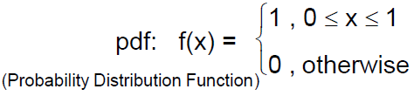
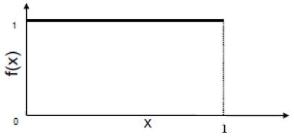
Expectation (Mean) E(R)
The expectation (or expected value) of a random variable R provides a measure of the central tendency, or the average value that R takes.
For a discrete random variable with probability mass function (PMF) p(r):
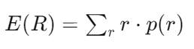
Example:
Consider a fair six-sided die.
The PMF is …
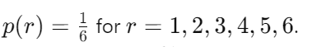
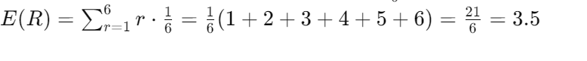
For a continuous random variable with probability density function (PDF) f(r):
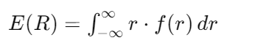
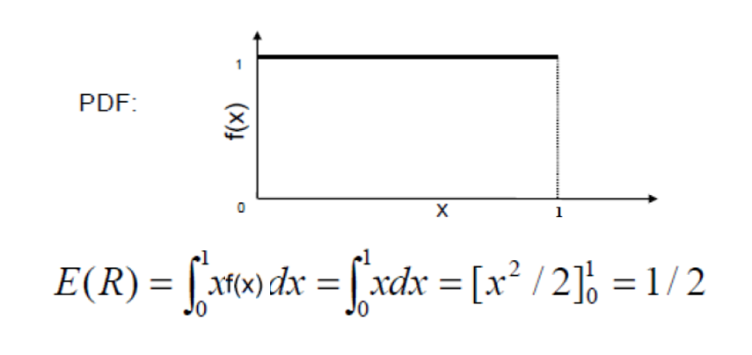
Variance V(R)
Variance is a statistical measure that quantifies the spread or dispersion of a set of data points. It indicates how much the individual data points in a dataset differ from the mean (average) of the dataset. The variance is particularly useful for understanding the degree of variability within the data.

The variance of a random variable R measures the spread or dispersion of the values around the mean. It is the expected value of the squared deviation of R from its mean μ=E(R).

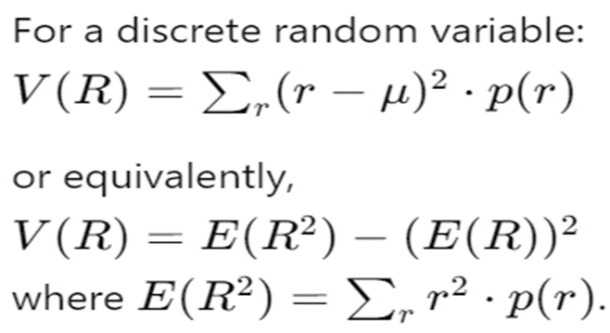

Example:
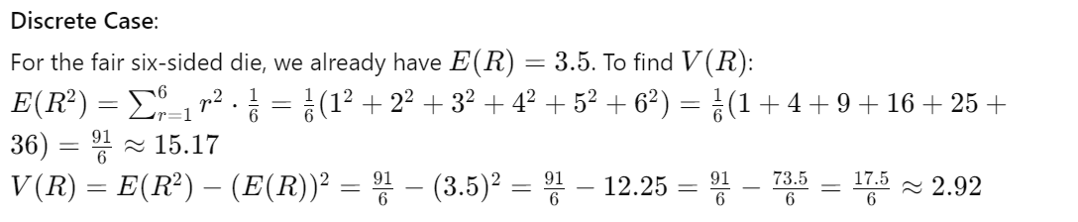
Continuous Case:
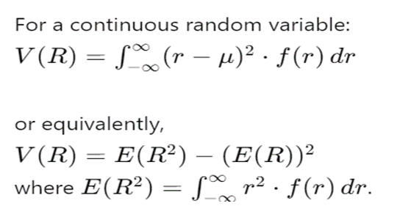
Example:
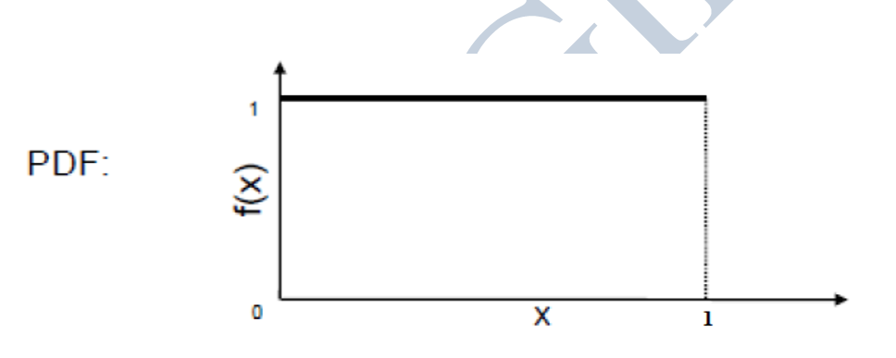

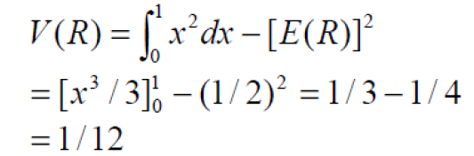

Types of Random Numbers:
There are three types of random numbers,
- True random numbers
- Pseudo random numbers
- Quasi random numbers
These different types of random numbers have different applications.

True Random Number:
True random numbers are gained from physical processes like radioactive decay (decomposition) or also rolling a dice. But rolling a dice is difficult perhaps someone could control the dice so well to determine the outcome.
The most often used example for “truly” random numbers is the decay of a radioactive material.
If a Geiger counter is put in front of such a radioactive source, the intervals between the decay events are truly random.
These random numbers are not generated by any algorithm but they are generated naturally from physical phenomenon and these are truly unpredictable, like events occurrence in nature.
Pseudo random numbers:
Pseudo-random numbers are generated using deterministic algorithms, typically involving mathematical functions or iterative procedures. Despite being generated algorithmically, they appear random and pass various statistical tests for randomness.
These numbers are generated by a computer or that is to say, by an algorithm and because of this not truly random, these can be predictive.
Since the arithmetic operation is known and the sequence of random numbers can be repeated, the numbers cannot be called truly random number.
When generating pseudo-random numbers, certain problems or errors can occur. Some examples of errors includes the following
- The generated numbers may not be uniformly distributed.
- The generated numbers may be discrete-valued instead continuous valued
- The mean of the generated numbers may be too high or too low.
- The variance of the generated numbers may be too high or low
- There may be dependence. The following are examples:
- Autocorrelation between numbers.
- Numbers successively higher or lower than adjacent numbers.
- Several numbers above the mean followed by several numbers below the mean.
Characteristics:
- Deterministic: The sequence can be reproduced if the initial seed value and the algorithm are known.
- Efficiency: Typically faster and more practical to generate compared to true random numbers.
- Applications: Widely used in simulations, gaming, statistical sampling, and non-cryptographic applications where true randomness is not crucial.
Example: The Mersenne Twister algorithm is a popular method for generating pseudo-random numbers.
Quasi random numbers:
Quasi-random numbers, also known as low-discrepancy sequences, are designed to fill a space more uniformly than pseudo-random numbers. Here, Lower discrepancy indicates that the points are more evenly spread out, covering the space more uniformly, which is the goal of quasi-random numbers.
They are used in numerical integration, computer graphics, and other applications where uniform coverage of a space is desirable. Unlike pseudo-random numbers, quasi-random numbers are deterministic and have patterns that minimize gaps and clusters.

Characteristics of Quasi-Random Numbers
- Deterministic: Quasi-random sequences are generated by deterministic algorithms, meaning they are reproducible and not random in the strict sense.
- Low Discrepancy: These sequences aim to cover a multi-dimensional space as uniformly as possible. Discrepancy measures the deviation between the uniform distribution and the actual distribution of points in the sequence.
- Efficiency in Integration: They are particularly effective in numerical integration, reducing the error compared to traditional Monte Carlo methods.

Random Number Generators
A random number generator is a hardware device or software algorithm that generates a number that is taken from a limited or unlimited distribution and outputs it. There are two main types of random number generators: pseudo-random and true random.

- A pseudo-random number generator (PRNG) is typically programmed using a randomizing math function to select a "random" number within a set range.

These random number generators are pseudo-random because the computer program or algorithm may have unintended selection bias. In other words, randomness from a computer program is not necessarily an organic, truly random event. They rely on algorithms to mimic the selection of a value to approximate true randomness. Pseudo random number generators work with the user setting the distribution, or scope from which the random number is selected (e.g. lowest to highest), and the number is instantly presented.

- A true random number generator (TRNG) relies on randomness from a physical event that is external to the computer and its operating system. Examples of such events are blips in atmospheric noise, or points at which a radioactive material decays. A true random number generator receives information from these types of unpredictable events to produce a truly random number.

Properties of Good random Number Generators:
Usually, random numbers are generated by a digital computer as part of the simulation. Numerous methods can be used to generate the values. In selecting among these methods, or routines, there are a number of important considerations.
Efficiency:
The generator should be computationally efficient, providing random numbers quickly to keep the simulation's overall cost and execution time low.

Portability: Cross-Platform Consistency:
The generator should be able to run on different computers and ideally in different programming languages without changes. This ensures that the simulation produces the same results regardless of the execution environment.

Long Cycle Length:
- Extended Period: The cycle length, or period should be sufficiently long to avoid repetition. For instance, if generating 10,000 events, the period should be much longer to prevent numbers from repeating in earlier sequences, which would degrade the quality of the simulation.

- Avoid Degeneration: The generator must not degenerate by producing the same numbers repetitively within a short period. This degradation can lead to unreliable and biased simulation results.

Replicability:
- Consistent Outputs: Given the same initial conditions or seed, the generator should produce the same sequence of random numbers. This feature is crucial for debugging, validation, and comparing different systems under identical conditions.

Statistical Properties:
- Uniformity: The random numbers should be uniformly distributed over the desired range, ensuring that each possible number has an equal chance of being selected.
- Independence: The generated numbers should be statistically independent, meaning the value of one number should not influence the value of another. This property is essential for accurately modeling random processes.

Period in Random Number:
In random number generation, the term "period" refers to the length of the sequence before a random number generator (RNG) repeats itself and starts producing numbers that have been previously generated. In other words, the period is the number of unique values that an RNG can generate before it cycles back to its initial state and starts producing the same sequence of numbers again.
For example, consider a simple random number generator that produces values between 0 and 9. If this generator has a period of 10, it means that after generating 10 unique values, it will start producing the same sequence of values all over again.

Methods of Generating Random Numbers:
There are several methods of Generating Random Numbers some of them are:
- Linear Congruential Method
- Mid-Square Method

Linear Congruential Method:
The linear congruential method, initially proposed by Lehrer [1951], produces a sequence of integers, X₁, X₂,... between zero to m-1 according to the following recursive relationship:
X_{i+1} = (a X_{i} + c) mod m ………………... Eq-1
Where, i=0,1,2,3………

Here…
X0​ | Seed | Initial value (starting point)
a | Multiplier | Controls randomness pattern
c | Increment | Adds shift to sequence
m | Modulus | Maximum range of values
Xi​ | Random integer | Generated value

Case 1: If c ≠ 0 in Eq-1, the form is called the mixed congruential method.
Case 2: When c = 0, the form is known as the multiplicative congruential method.
The selection of the values for a, c, m and X₀ drastically affects the statistical properties and the cycle length.
Let’s illustrate the different congruential Methods with the help of example.

Mixed Congruential Method: c ≠ 0
Let a = 9, c = 3 , m = 31 & X₀ = 2
We know that,
X_{i+1} = (a X_{i} + c) mod m
Then,
X₁ = (aX₀ + c) mod m
= (9*2 + 3) mod 31
= 21 mod 31
X₁= 21
X₂ = (aX₁ + c) mod m
= ( 9*21 + 3) mod 31
= 192 mod 31
X₂= 6
And X₃=26 , X₄=20, X₅=28
Hence, random numbers are 2,21,6,26,20,28,7,4,8

Multiplicative Congruential Method: c = 0
Let a = 9, m = 31 & X₀ = 2
We know that,
X_{i+1} = (a X_{i} + c) mod m
If c = 0, then
X_{i+1} = (a X_{i}) mod m
X₁ = (aX₀) mod m
= (9*2) mod 31
= 18 mod 31
X₁= 18
X₂ = (aX₁) mod m
= ( 9*18) mod 31
= 162 mod 31
X₂ = 7
And X₃=1, X₄=9, X₅=19
Hence, random number are 2,18,7,1,9,19,16,20…..

Additive Congrutial Method: a =1
Let c = 17, m = 29 & X0 = 7
We know that,
X_{i+1} = (a X_{i} + c) mod m
If a =1, then
X_{i+1} = (X_{i} + c) mod m
X₁ = (X₀ + c) mod m
= (7 + 17) mod 29
= 24 mod 29
X₁= 24
X₂ = (X₁ + c) mod m
= (24 + 17) mod 29
= 41 mod 29
X₂= 12
And X₃=0, X₄=17, X₅=5
Hence, random number are 7,24,12,0,17,5,22,10,27…….

Arithmetic Congruential Method:
In this method random number are generated by the equation:
X_{i+1} = (X_{i-1} + X_{i}) mod m
Let, X₁=9, X₂=13, m=17
Then,
X₃=(X₁ + X₂) mod m
= (9 + 13) mod 17
X₃= 5
X₄=(X₂ + X₃) mod m
= (13 + 5) mod 17
X₄ = 1
………………..
So
The random numbers are 9,13,5,1,6,7,13,3………..

Example 1:
Use the linear congruential method to generate a sequence of random numbers with X₀ = 27, a= 17, c = 43, and m = 100. Here, the integer values generated will all be between zero and 99 because of the value of the modulus. These random integers should appear to be uniformly distributed the integers from zero to 99. Random numbers between zero and 1 can be generated by:
R_{i} =X_{i} / m ………………….Eq-2
Where, i = 1,2,3,……

Solution
The sequence of X_{i} and subsequent R_{i} values is computed as follows:
X₀ = 27
X₁ = (aX₀ + c) mod m
X₁ = (17*27 + 43) mod 100
= 502 mod 100
X₁ = 2
R₁ = X₁ / m
= 2⁄100
R₁=0.02
X₂ = (aX₁ + c) mod m
X₂ = (17*2 + 43) mod 100
= 77 mod 100
X₂= 77
R₂ = X₂ / m
R₂ =77 ⁄ 100
R₂=0.77
Likewise,
X₃ = (17 x 77+ 43) mod 100
= 1352 mod 100
X₃= 52
R₃=52 ⁄100
R₃=0.52

Example 2:
Let m = 100, a = 19, c = 0, and X₀ = 63. Generate a sequence of random integers using X_{i+1} = (a X_{i} + c) mod m.

Solution:
X₀ = 63
X₁ = (19*63) mod 100
= 1197 mod 100
X₁= 97
X₂ = (19*97) mod 100
= 1843 mod 100
X₂= 43
X₃ = (19*43) mod 100
= 817 mod 100
X₃ = 17
………..

Example 3:
Using the multiplicative congruential method, find the period of the generator for a = 13, m = 64, and X₀ = 1, 2, 3, and 4. Prove that the solution is given , when the seed is 1 and 3, the sequence has period 16, a period of length eight is achieved when the seed is 2 and a period of length four occurs when the seed is 4.

Solution:
Following table shows the periods of random number with different seeds:
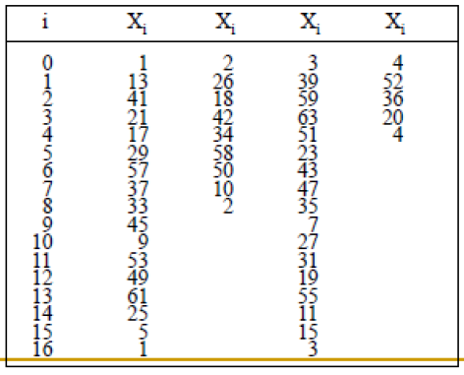
Here, we can see,
If seed is 1 and 3 period is 16 i.e. after 16th random number seed is repeated.
If seed is 2 period is 8 and if seed is 4 period is 4.

Assignment
- Let m = 100, a = 19, c = 0, and X0 = 63, and generate a sequence random integers. Find first 7 random numbers generate using any suitable method?
- Let a = 7⁵=16,807, m = 2³¹-1 = 2,147,483,647 (a prime number), and c= 0. These choices satisfy the conditions that insure a period of P = m-1. Further, specify a seed, X₀ = 123,457.
- Let m = 47, a = 19, and X0 = 46, and generate a sequence c random integers. Find first 4 random numbers generate using any suitable method?
- Let m = 100, a = 19, c = 6, and X0 = 63, and generate a sequence c random integers. Find first 5 random numbers generate using any suitable method?
- Find random number, with first two random numbers is 10 and 15 respectively with modulus 50.

Mid Square Method:
This method was proposed by Van Neumann. In this method, we have a seed and then the seed is squared and its midterm is fetched as the random number.
Step 1: Take a m digits seed number N₀
Step 2: Get square of seen number N₀² = N₀*N₀
Step 3: Square should be double digits of seed i.e. 2m, if it is not then add zeros at the beginning to make double
Step 4: Take m digits from middle as a next random number. Then make this as a seed for next number.
Step 5: Go to Step 2
Step 6: Repeat these steps until same number chain occurs
Consider we have a seed having N digits we square that number to get a 2N digits number if it doesn’t become 2N digits we add zeros before the number to make it 2N digits.
This algorithm is basically the one which does not depend on the seed and the period should also be maximally long that it should almost touch every number in its range before it starts repeating itself as a rule of thumb remember that longer the period more random is the number.

Example:
Consider the seed to be 14 and we want a two digit random number.
Number --> Square --> Mid-term
14 --> 0196 --> 19
19 --> 0361 --> 36
36 --> 1296 --> 29
29 --> 0841 --> 84
84 --> 7056 --> 05
05 --> 0025 --> 02
02 --> 0004 --> 00
00 --> 0000 --> 00
In the above example, we can notice that we get some random numbers 19,36,29,84,05,02,00 which seem to be random picks, in this way we get multiple random numbers until we encounter a self-repeating chain.
We also get to know a disadvantage of this method that is if we encounter a 0 then we get a chain of 0s from that point.
Also, consider that we get a random number 50 the square will be 2500 and the midterms are 50 again, and we get into this chain of 50, and sometimes we may encounter such chains more often which acts as a disadvantage and because of these disadvantages this method is not practically used for generating random numbers.

Random Variate Generation (Non Uniform Random Number Generation)
A random variable is a measurable mapping having some distribution, and a random Variate is just a member of the co-domain of a random variable. A random Variate is a particular outcome of a random variable. Random Variates are the samples generated from a known distribution i.e. Random Variable and Random Variates have an inverse relationship.
Suppose X is a random variable which stands for the outcome of tossing a fair dice. So X can take value from 1 through 6 with equal probability of 1/6. Now you actually toss a dice and get a number 4. This number is a particular outcome of X, and thus a random Variate. If you toss again, you may get another different value.
There are two popular methods for generate Random Variate:
- Inverse Transform Method
- Acceptance/Rejection Method

Inverse Transform Method(Non Uniform Transformation Method)
The inverse transform technique can be used to sample from the:
- Exponential Distribution
- Uniform Distribution
- Triangular distribution
By inversing the Cumulative Distribution Function (CDF) of those probability distributions, the inverse transform technique can be utilized for any distribution when the CDF, F(x), is of a form that its inverse, F⁻¹ can be computed easily.

a) Exponential Distribution
The exponential distribution has the Probability Distribution Function (PDF):
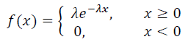
And the Cumulative Distribution Function (CDF)
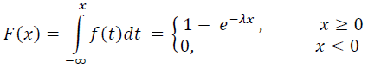
λ is the number of occurrences per unit time.
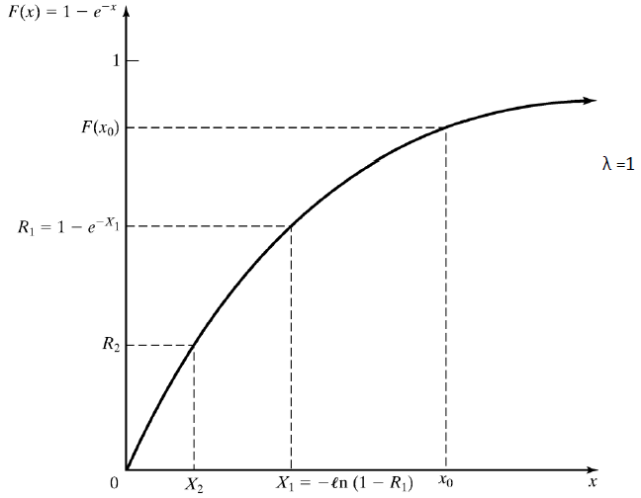
The random Variate generation process is summarized in following steps:
- Compute the Cumulative Distribution Function (CDF) for exponential distribution:
F(X)= 1− 𝑒^{−𝜆𝑋}
where λ is the rate parameter of the exponential distribution.
- Set the CDF (i.e. F(X)) equal to a uniform random number R on the range of X:
1− 𝑒^{−𝜆𝑋} =R
3. Solve the equation 1− 𝑒^{−𝜆𝑋}=𝑅 in terms of X.
a. Rearrange the equation to isolate the exponential term:
1− 𝑒^{−𝜆𝑋}=𝑅
𝑒^{−𝜆𝑋}=1−𝑅
b. Take the natural logarithm (ln) of both sides to remove the exponential:
−𝜆𝑋= ln(1− 𝑅)
c. Solve for X:
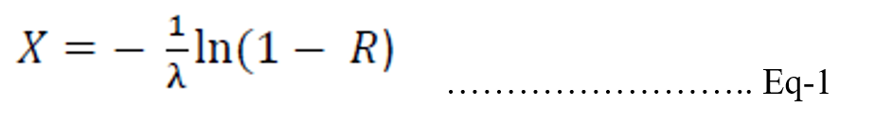
Eq-1 is called random Variate generator for the exponential distribution.
In general Eq-1 is written as
X = F ^{– 1}(R)

Example:
Generation of Exponential Variates X_{i} with mean 1 (i.e. λ=1), given random numbers R_{i}

Solution:
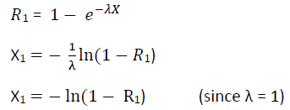
X₁ = -ln(1-0.1306)
= -ln(0.8694)
X₁= 0.1400
X₂ = -ln(1-0.0422)
= -ln(0.9578)
X₂= 0.0431
X₃ = -ln(1-0.6597)
= -ln(0.3403)
X₃= 1.0779
X₄ = -ln(1-0.7965)
= -ln(0.2035)
X₄= 1.5920
X₅ = -ln(1-0.7696)
= -ln(0.2304)
X₅ = 1.4679
Then the veriats of given Random numbers are:
X₁ | X₂ | X₃ | X₄ | X₅
0.1400 | 0.0431 | 1.0779 | 1.5920 | 1.4679

Assignment:
- Generation of Exponential Variates X_{i} with number of occurrence per unit time is 3, given random numbers R_{i}
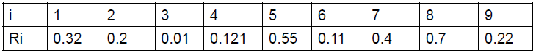

b) Uniform Distribution:
The PDF for X in uniform distribution is given by
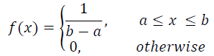

Here, a and b are the parameters of the distribution, representing the lower and upper bounds of the interval, respectively. This means that the PDF is constant (i.e., 1/b−a​) for all x in the interval [a,b] and zero outside this interval.

And the CDF is given by
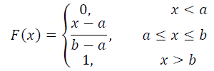

Here,
- a and b are the parameters of the uniform distribution.
- a is the lower bound of the interval, that is, a represents the minimum value X can take.
- b is the upper bound of the interval that is b represents the maximum value X can take.

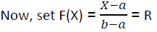
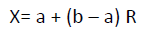 ………………… Eq-2

Eq-2 is the random Variate generator for the uniform distribution.

Assignment:
- Generation of Uniform Distribution X_{i} with number of given random numbers R_{i} , where a=0.2, b=0.9
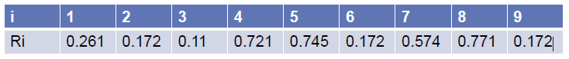

c) Triangular Distribution
The probability density function (PDF) of the triangular distribution is given by:
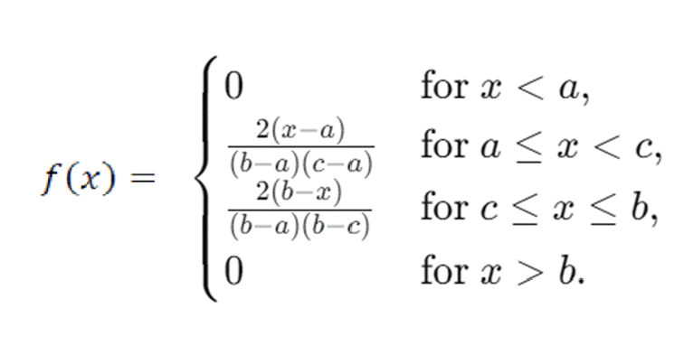
Here,
- a: The minimum value.
- b: The maximum value.
- c: The mode (the value at which the PDF reaches its maximum).

The probability density function (PDF) of the triangular distribution with endpoints (0, 2) and mode at 1 is given by
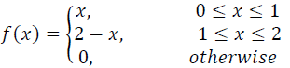

The cumulative distribution function (CDF) F(x) of the triangular distribution is given by:
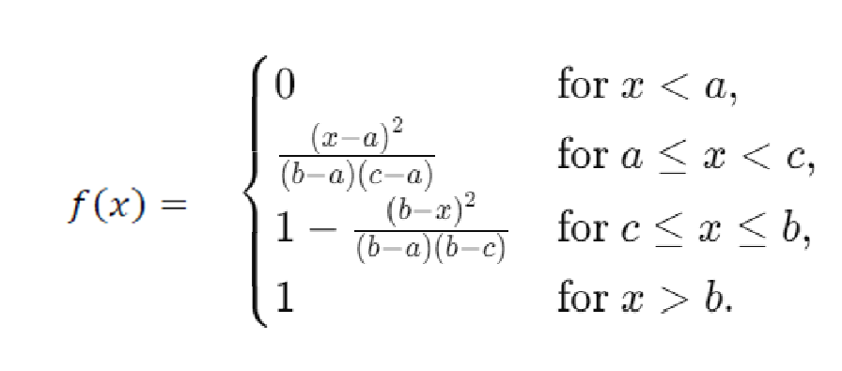
The CDF of the triangular distribution with endpoints (0, 2) and mode at 1 is given by
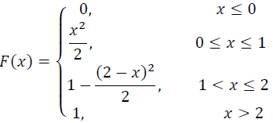
To generate random variates X from a triangular distribution…in above case
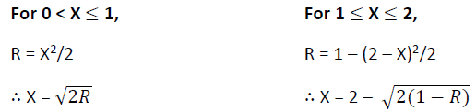
Hence…..
If R<(c-a)/(b-a) then.
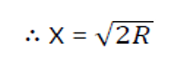
Otherwise…
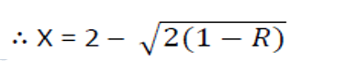

Inverse Transform Method:
To generate random variates X from a triangular distribution defined by parameters a, b, and c, where a is the minimum, b is the maximum, and c is the mode, you can use the inverse transform method based on the cumulative distribution function (CDF).
The CDF F(x) of the triangular distribution is given by:


Steps to generate random variates X from this distribution:
- Generate R: Generate a uniform random number R between 0 and 1.
- Determine the Range:

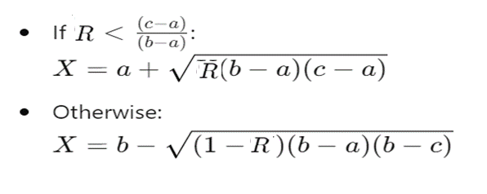
This procedure ensures that X follows the triangular distribution with parameters a, b, and c. Each step involves straightforward calculations based on the inverse CDF formula derived from the properties of the triangular distribution.

Acceptance/Rejection Method:
The Acceptance-Rejection method is a popular technique used in random variate generation to generate random numbers from a specified probability distribution that might be complex or hard to sample directly. This method involves using a simpler and easily sampleable distribution to generate random samples that are then adjusted to match the desired distribution using acceptance or rejection criteria.
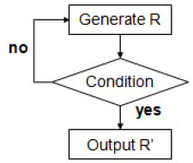
Use following steps to generate uniformly distributed random variate between 1/4 and 1.
Step 1: Generate a random number R~ U[0,1]
Step 2:
a:
b:
Step 3: If another uniform random variate on [1/4, 1] is needed, repeat the procedure beginning at Step 1, Otherwise stop.

Test for Randomness:
The desirable properties of random numbers are uniformity and independence to ensure that these desirable properties are achieved, a number of tests can be performed (fortunately, the appropriate tests have already been conducted for most commercial simulation software). The tests can be placed in two categories according to the properties of interest.
- Testing for uniformity
- Testing for independence.

Uniformity Test:
The testing for uniformity can be achieved through different frequency test. These tests use the Kolmogorov-Smirnov (K-S) or the Chi-Square test to compare the distribution of the set of numbers generated to a uniform distribution. Hence in this category we will discuss two types of test
- Kolmogorov-Smirnov (K-S) Test
- Chi-Square Test
In testing for uniformity, the hypotheses are as follows:
- Null hypotheses (H₀): R_{i} ~U/[0, 1]
- Alternative hypothesis (H₁): R_{i} !~U/[0, l]
Here U is the uniformity
The null hypothesis, H₀ reads that the numbers are distributed uniformly on the interval [0, 1] and alternative hypothesis H₁ reads that the numbers are distributed not uniformly on the interval [0, 1]. Failure to reject the null hypothesis means that no evidence of non-uniformity has been detected on the basis of this test. This does not imply that further testing of the generator for uniformity is unnecessary.
For each test, a level of significance (α) must be stated. The level α is the probability of rejecting the null hypothesis given that the null hypothesis is true…
α = P (reject H₀ | H₀ true)
The decision maker sets the value of α for any test. Frequently, α is set to 0.01 or 0.05.

The Kolmogorov-Smirnov (K-S) Test:
This test compares the continuous cumulative distribution function F(x), of the uniform distribution to the empirical cumulative distribution function S_{N}(x), of the sample of N observations.
By definition,
F(x) = x, 0 <= x <= 1
If the sample from the random-number generator is R₁ R₂, • • •, R_{N}, then the empirical cumulative distribution function, S_{N}(x), is defined by
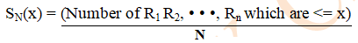
Where N is the number of observations, As N becomes larger, S_{N}(x) should become a better approximation to F(x), provided that the null hypothesis is true.
The Kolmogorov-Smirnov (K-S) test is based on the largest absolute deviation or difference between F(x) and S_{N}(x) over the range of the random variable i.e. it is based on the statistic
D = max | F(x) - S_{N}(x)|
Here, D is the test statistic that quantifies the largest absolute difference between the empirical distribution function (EDF) of the sample and the cumulative distribution function (CDF) of the reference distribution.

For testing against a uniform cumulative distribution function, the test procedure follows these steps:

Algorithm for K-S Test:
Step 1: Define the hypothesis for testing uniformity
H₀ : R_{i} ~ Uniformity
H₁ : R_{i} !~ Uniformity
Step 2: Sort the data from smallest to largest. Let R_{(i)} denoted the i th smallest observation, so that R₍₁₎ <= R₍₂₎ ……..<=R_{(N)}
Step 3: Compute both the maximum positive differences D+ and negative difference D-.

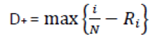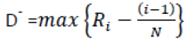
Step 4: Compute (The Kolmogorov-Smirnov statistic D)

D = max{D⁺, D⁻}
Step 5: Determine the critical value, D_{α} from K-S table for Critical Values for the specified significance level α and the given sample size N.
Step 6:
If D <= D_{α}:
The null hypothesis (H₀) is accepted, i.e. the numbers are uniformly distributed.
Else
The null hypothesis (H₀) is rejecter, i.e. the numbers are not uniformly distributed.

K-S table for Critical Values
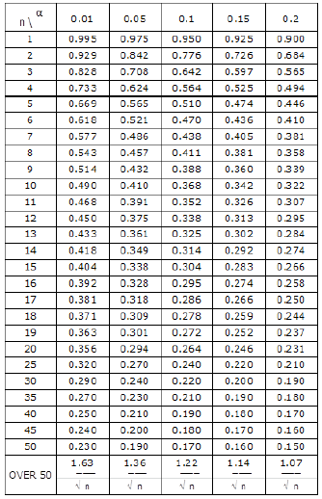
Example: Suppose that the five random numbers 0.44, 0.81, 0.14, 0.05, 0.93 were generated, and it is desire to perform a test for uniformity using the K-S test with a level of significance α of 0.05.

Solution:
Define hypothesis for testing uniformity
H₀ : R_{i} ~ uniformity
H₁ : R_{i} !~ uniformity
First, the numbers must be sorted from smallest to largest, i.e. the given random numbers are 0.05, 0.14, 0.44, 0.81, 0.93
N = 5
Now calculate the D⁺ and D⁻ as:
i | 1 | 2 | 3 | 4 | 5
R_{i} | 0.05 | 0.14 | 0.44 | 0.81 | 0.93
i/N | 1/5=0.2 | 2/5=0.4 | 3/5=0.6 | 4/5=0.8 | 5/5=1.0
(i-1)/N | (1-1)/5=0 | (2-1)/5=0.2 | (3-1)/5=0.4 | (4-1)/5=0.6 | (5-1)/5=0.8
D⁺ = (i/N)-R_{i} | 0.15 | 0.26 | 0.16 | -0.01 | 0.07
D⁻ =  R_{i} –((i-1)/N) | 0.05 | -0.06 | 0.04 | 0.21 | 0.13

New, max {D⁺} = 0.26 max {D⁻} = 0.21
D = max {D⁺, D⁻} = max{0.26, 0.21}
D = 0.26
D_{0.05} at N=5 = 0.565 (See in K-S Table for Critical Values)
D_{0.05} = 0.565
Here D < D_{0.05} hence null hypothesis is accepted
This shows that according to KS testing given numbers are uniformly distributed.
Assignment
- Suppose that the five numbers 0.24, 0.80, 0.11, 0.05, 0.93 were generated, and it is desired to perform a test for uniformity using the Kolmogorov-Smirnov test with a level of significance α of 0.01.
- Suppose that the four numbers 0.80, 0.14, 0.05, 0.5 were generated, and it is desired to perform a test for uniformity using the Kolmogorov-Smirnov test with a level of significance α of 0.10.
- Suppose that the seven numbers 0.44, 0.81, 0.14, 0.05, 0.93, 0.01, 0.02 were generated, and it is desired to perform a test for uniformity using the Kolmogorov-Smirnov test with a level of significance α of 0.05.

Chi-Square Test:
Note: It is pronounced as Kaai Square Test
A chi-squared test (symbolically represented as X²) is basically a data analysis on the basis of observations of a random set of variables. Usually, it is a comparison of two statistical data sets. This test was introduced by Karl Pearson in 1900 for categorical data analysis and distribution. So, it was mentioned as Pearson’s chi-squared test.
The chi-square test is used to estimate how likely the observations that are made would be, by considering the assumption of the null hypothesis as true.
A hypothesis is a consideration that a given condition or statement might be true, which we can test afterwards. Chi-squared tests are usually created from a sum of squared falsities or errors over the sample variance.
Chi-Square test uses the sample statistics as:
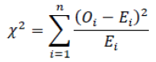
Where,
O_{i} is the observed number in the i-th class,
E_{i} is the expected number in the i-th class,
n is the number of classes.
For the uniform distribution, E_{i} the expected number in each class is given by:
E_{i} = N/n
For equally spaced classes, N is the total number of observations. It can be shown that the sampling distribution of X₀² is approximately the chi-square distribution with n-1 degrees of freedom.
Algorithm for Chi-Square Test:
Step 1: Define the hypothesis for testing uniformity
H₀ : R_{i} ~ Uniformity
H₁ : R_{i} !~ Uniformity
Step 2: Determine Order Statistics
R₁<=R₂<=…….R_{n}
Step 3: Divide Range R_{n} – R₁ in n equidistant intervals [a_{i}, b_{i}], such that each interval has at least 5 observations.
Step 4: Calculate for i = 1,2,3.....,N
O_{i} = N.{S_{N}(b_{i}) - S_{N}(a_{i})},
E_{i} = N.{F(b_{i}) – F(a_{i})}
Step 5: Calculate

Step 6: Determine the critical value of X² _{α,n-1} from chi-square table
Step 7:
If X² <= X² _{α,n-1}
Null hypothesis is accepted, that means random numbers are uniformly distributed
Else
Null hypothesis is rejected, that means random numbers are not uniformly distributed

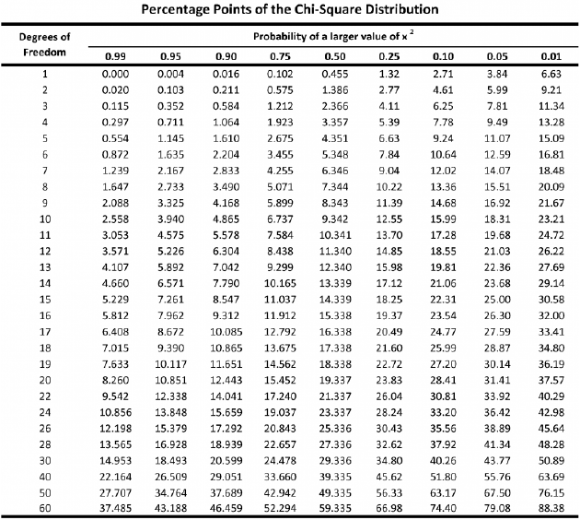

Example 1: Use the chi-square test with α = 0.05 to test whether the data shown below are uniformly distributed.
0.34 0.83 0.96 0.47 0.79 0.99 0.37 0.72 0.06 0.18
0.90 0.76 0.99 0.30 0.71 0.17 0.51 0.43 0.39 0.26
0.25 0.79 0.77 0.17 0.23 0.99 0.54 0.56 0.84 0.97
0.89 0.64 0.67 0.82 0.19 0.46 0.01 0.97 0.24 0.88
0.87 0.70 0.56 0.56 0.82 0.05 0.81 0.30 0.40 0.64
0.44 0.81 0.41 0.05 0.93 0.66 0.28 0.94 0.64 0.47
0.12 0.94 0.52 0.45 0.65 0.10 0.69 0.96 0.40 0.60
0.21 0.74 0.73 0.31 0.37 0.42 0.34 0.58 0.19 0.11
0.46 0.22 0.99 0.78 0.39 0.18 0.75 0.73 0.79 0.29
0.67 0.74 0.02 0.05 0.42 0.49 0.49 0.05 0.62 0.78

Solution:
Here given,
α = 0.05, N = 100
Now, we can make 10 classes with equal length of 10 to each class
i.e. n = 10
Define hypothesis for testing uniformity
H₀ : R_{i} ~ uniformity
H₁ : R_{i} !~ uniformity
The table for Chi-Square statistics is
Class Interval (i) | O_{i} | E_{i} =(N/n) | (O_{i} - E_{i}) | (O_{i} - E_{i})² | X² = (O_{i} - E_{i})²/E_{i}
1 (0.0, 0.1) | 8 | 10 | -2 | 4 | 0.4
2 (0.1, 0.2) | 8 | 10 | -2 | 4 | 0.4
3 (0.2, 0.3) | 10 | 10 | 0 | 0 | 0
4 (0.3, 0.4) | 9 | 10 | -1 | 1 | 0.1
5 (0.4, 0.5) | 12 | 10 | 2 | 4 | 0.4
6 (0.5, 0.6) | 8 | 10 | -2 | 4 | 0.4
7 (0.6, 0.7) | 10 | 10 | 0 | 0 | 0
8 (0.7, 0.8) | 14 | 10 | 4 | 16 | 1.6
9 (0.8, 0.9) | 10 | 10 | 0 | 0 | 0
10 (0.9, 1.0) | 11 | 10 | 1 | 1 | 0.1
Total | N=100 | N=100 |  |  | ⅀X² = 3.4

Note: The value of O_{i} at interval 1 (0.0, 0.1) is total data between range greater than 0.0 and less than or equals to 0.1 i.e. (0.0 < data <= 0.1) there are 8 data presented in this range. Likewise for all the value of O_{i} for all intervals are calculated.
The value of X² = 3.4
Now, find the value of Chi-Square i.e. X²_{α, n-1} from table.
Here degree of freedom is n-1=10-1=9 and α=0.05.
The tabulated value of X²_{0.05, 9} =16.9
Here, X² < X²_{0.05, 9} hence null hypothesis is accepted.
This shows that according to Chi-Square test the given numbers are uniformly distributed.

Example 2: Use the chi-square test with α = 0.05 to test whether the data shown below are uniformly distributed. In first ranges there are 15 random number , in second there are 5 random number, in 3rd there are 10 random number, in fourth there are 10 and in 5th there are 20 random number.

Solution:
Here given,
Total number of classes (n) = 5
Total random numbers (N) = 15+5+10+10+20 = 60
Define hypothesis for testing uniformity
H₀ : R_{i} ~ uniformity
H₁ : R_{i} !~ uniformity

The table for Chi-Square statistics is
Class Interval (i) | O_{i} | E_{i} (N/n) | (O_{i} - E_{i}) | (O_{i} - E_{i})² | X² = (O_{i} - E_{i})²/E_{i}
1 | 15 | 12 | 3 | 9 | 9/12=0.75
2 | 5 | 12 | -7 | 49 | 49/12=4.08
3 | 10 | 12 | -2 | 4 | 4/12=0.33
4 | 10 | 12 | -2 | 4 | 4/12=0.33
5 | 20 | 12 | 8 | 64 | 64/12=5.33
Total | N=60 | N=60 |  |  | ⅀X² = 10.82

Value of X² = 10.82
Now, find the value of Chi-Square i.e. X²_{α, n-1} from table.
Here degree of freedom is n-1=5-1= 4 and α=0.05.
The tabulated value of X²_{0.05, 4} = 9.49
Here, X² > X²_{0.05, 4} hence null hypothesis is rejected.
This shows that according to Chi-Square test the given numbers are not uniformly distributed.

Conclusion:
Both the Kolmogorov-Smirnov and the chi-square test are acceptable for testing the uniformity of a sample of data, provided that the sample size is large. However, the Kolmogorov-Smirnov test is the more powerful of the two and is recommended. Furthermore, the Kolmogorov-Smirnov test can be applied to small sample sizes, whereas the chi-square is valid only for large samples, say N>=50.
Assignment:
- Use the chi-square test with α = 0.99 to test whether the data shown below are uniformly distributed. In first ranges there are 10 random number, in second there are 10 random number, in 3rd there are 15 random number, in fourth there are 15 , in 5th there are 5 random number. And then 6th, 7th and 8th has 10, 5, 10 random numbers.
- Use the chi-square test with a = 0.25 to test whether the data shown below are uniformly distributed. In first ranges there are 20 random number , in second there are 9 random number, in 3rd there are 15 random number, in fourth there are 15 and in 5th there are 13 random number.

K-S Test V/s Chi-Square Test:
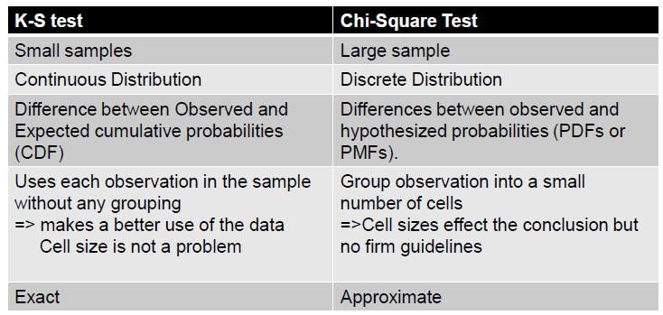

Independence Testing:
An independence test of random numbers refers to a statistical test used to determine whether a sequence of random numbers generated by a random number generator (RNG) exhibits a significant level of independence between consecutive numbers. In other words, the test aims to assess whether the generated sequence of numbers is truly random or if there are patterns, correlations, or dependencies present that might indicate a lack of randomness.
There are three types of popular testing for independence as:
- Autocorrelation Test: It tests the correlation between numbers and compares the sample correlation to the expected correlation of zero.
- Gap Test: It counts the number of digits that appear between repetitions of particular digit and then uses the Kolmogorov-Smirnov test to compare with the expected size of gaps,
- Poker Test: It treats numbers grouped together as a poker hand. Then the hands obtained are compared to what is expected using the chi-square test.

Autocorrelation Test:
Autocorrelation Test is a statistical test that determines whether a random number generator is producing independent random number in a sequence. The test for the auto correlation is concerned with the dependence between numbers in a sequence. The test computes the auto correlation between every m numbers (m is also known as lag) starting with i^{th} index.
To calculate the largest integer…
i+(M+1)m<=N
The variables involved in this test are:
- m is the lag, the space between the number being tested.
- i is the index or number from we start the testing.
- N is the total number of random numbers generated.
- M is the largest integer such that i+(M+1)m<=N
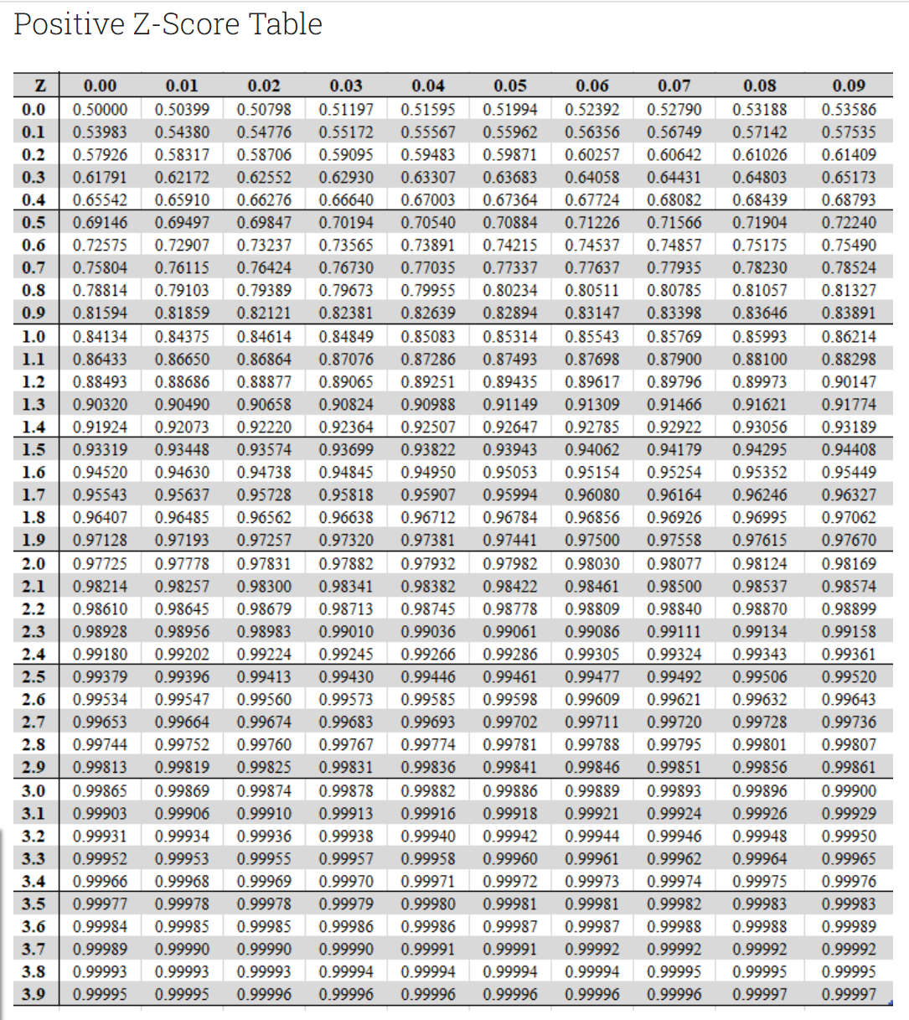
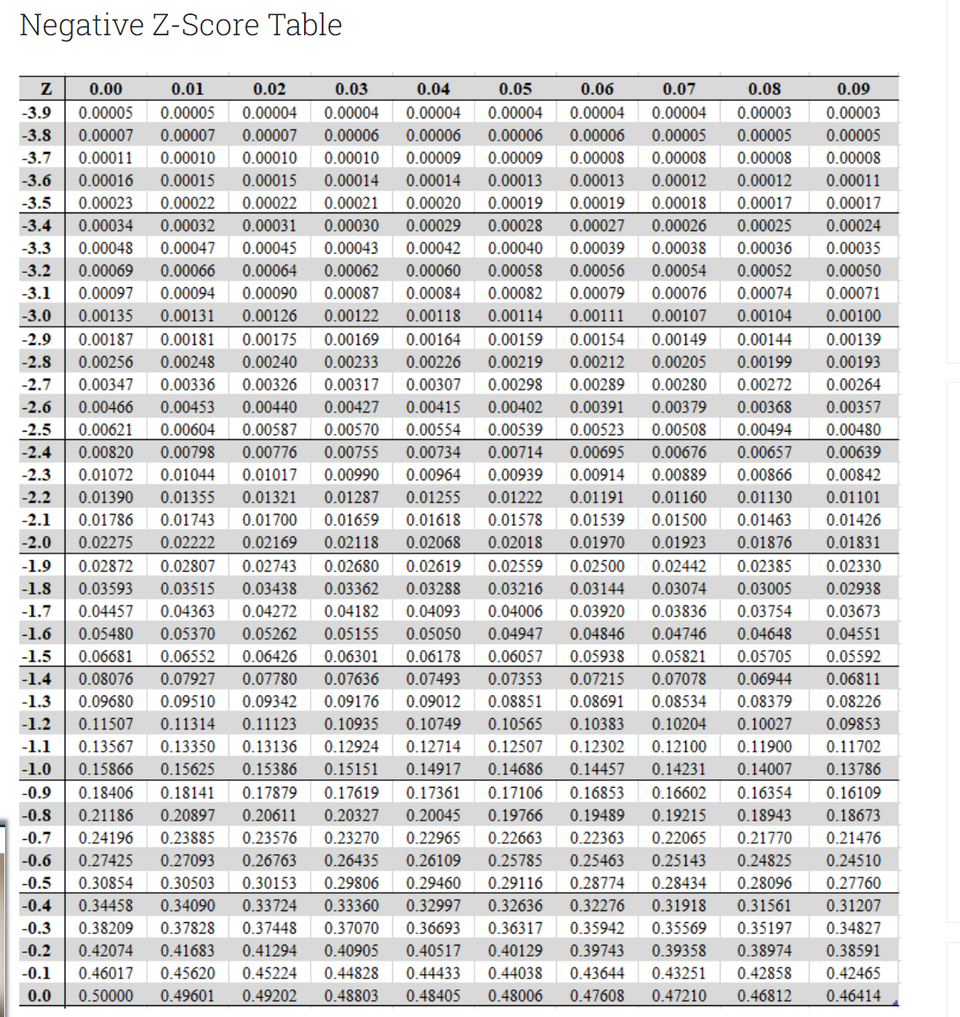

Algorithm for Autocorrelation Test:
Step 1: Define the hypothesis for testing independence
H₀ : R_{i} ~ independence
H₁ : R_{i} !~ independence
Step 2: Now the autocorrelation ρ_{im} between R_{i}, R_{i+m}, R_{i+2m},.……R_{i+(M+1)m} is computed as:
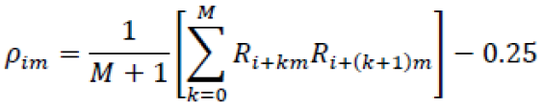
Step 3: Now, calculate the test statistics as:
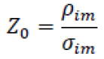
Where,
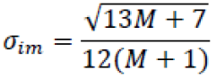

Step 4: find the critical value of Z_{α/2} from Z table
Step 5:
If Z₀ <= Z_{α/2},
Null hypothesis (H₀) is accepted, that means random number are independent
Else
Null hypothesis (H₀) is rejected, that means random number are not independence.
Note:
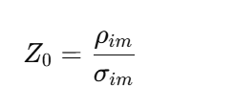
- Z_{0​} is the test statistic.
- ρ_{im}​ represents the sample autocorrelation at lag m.
- σ_{im}​ represents the standard deviation of ρim​, which is the standard error of the autocorrelation estimate.

Example: Test whether the 3rd, 8th, 13th, and so on, numbers in the sequence at the beginning of this section are auto-correlated. (Use α = 0.05.) Here, i = 3 (beginning with the third number), m = 5 (every five numbers), N = 30 (30 numbers in the sequence). Use Z_{0.025} = 1.96
0.12 0.01 0.23 0.28 0.89 0.31 0.64 0.28 0.83 0.93 0.99 0.15 0.33 0.35 0.91 0.41 0.60 0.27 0.75 0.88 0.68 0.49 0.05 0.43 0.95 0.58 0.19 0.36 0.69 0.87

Solution:
Define hypothesis for testing independence
H₀ : R_{i} ~ independence
H₁ : R_{i} !~ independence
First we calculate the value of M using the condition
i + (M+1)m <= N
Since, i=3, m=5, and N=30 we have
3 + (M +1)5 <= 30
3 + 5M + 5 <=30
5M <= 22
M <= 22/5
M <= 4
Hence, M=4
Then,

ρ₃₅ = 1/(4+1)[R_{3+0*5} * R₃₊₍₀₊₁₎₅ + R_{3+1*5} * R₃₊₍₁₊₁₎₅+ R_{3+2*5} * R₃₊₍₂₊₁₎₅ + R_{3+3*5} * R₃₊₍₃₊₁₎₅ + R_{3+4*5} * R₃₊₍₄₊₁₎₅] – 0.25
ρ₃₅ = 1/(4+1)[R₃ R₈ + R₈ R₁₃+ R₁₃ R₁₈ + R₁₈ R₂₃ + R₂₃ R₂₈] – 0.25
ρ₃₅ = 1/(4+1)[(0.23)(0.28) + (0.28)(0.33) + (0.33)(0.27) + (0.27)(0.05) + (0.05)(0.36) ] – 0.25
ρ₃₅ = - 0.1945
Now,

σ₃₅ = √ (13(4) + 7) / 12(4 + 1)
σ₃₅ = 0.1280
Now the test statistics is:

Z₀ = - 0.1945/0.1280
Z₀ = - 1.5195
Now, the critical value of Z_{α/2} is
Z_{α/2} = Z_{0.05/2} = Z_{0.025}
Z_{0.025} = 1.96
Here Z₀ < Z _{0.025} hence null hypothesis is accepted
This shows that according to autocorrelation testing given data is independent.

Gap Test:
The gap test is used to determine the significance of the interval between the recurrences of the same digit. A gap of length x occurs between the recurrences of some specified digit.
The following example illustrates the length of gaps associated with the digit 3:
4, 1, 3, 5, 1, 7, 2, 8, 2, 0, 7, 9, 1, 3, 5, 2, 7, 9, 4, 1, 6, 3 , 3, 9, 6, 3, 4, 8, 2, 3, 1, 9, 4, 4, 6, 8, 4, 1, 3.
There are 7 three’s are there. Thus only six gaps can occur. The first gap is of length 10 and second gap of length 7, Third gap of length 0, fourth gap of length 2, fifth gap of length 3 and sixth gap of length 8. Similarly, the gap associated with other digits can be calculated.
The probability of a particular gap length can be determined by:
P(gap of n) = P(n followed by exactly x non-n digits)
Where, n is the specified digit, x is the non-n digits. In above equation we consider the n = 3
If we are only concerned with digits between 0 and 9, then
The Theoretical Frequency Distribution F(x) for randomly ordered digits is given by
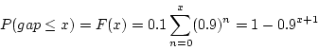

Algorithm for Gap Test:
The procedure for the test follows the steps below. When applying the test to random numbers, class intervals such as [0, 0.1), [0.1, 0.2),. . . play the role of random digits.
Step 1: Define the hypothesis for testing independence
H₀ : R_{i} ~ independence
H₁ : R_{i} !~ independence
Step 2: Specify the CDF for the Theoretical Frequency Distribution based on the selected class interval width.
F(x) = 1-0.9^{x+1}
Where x is the upper limit of gap length
Step3: Arrange the observed sample of gaps in a cumulative distribution S(x) with these same classes.
Step 4: Find D, the maximum deviation between F(x) and S(x) as in K-S test.
Step 5: Determine the critical value, D_{α}, from Table for the specified value of α and the sample size N.
Step 6:
If D < D_{α}
Null hypothesis is accepted, that means random numbers are independently distributed
Else
Null hypothesis is rejected, that means random numbers are not independently distributed

Example: Based on the frequency with which gaps occur, analyze the 110 digits below to test whether they are independent. Use α = 0.05.
4, 1, 3, 5, 1, 7, 2, 8, 2, 0, 7, 9, 1, 3, 5, 2, 7, 9, 4, 1, 6, 3, 3, 9, 6, 3, 4, 8, 2, 3, 1, 9, 4, 4, 6, 8, 4, 1, 3, 8, 9, 5, 5, 7, 3, 9, 5, 9, 8, 5, 3, 2, 2, 3, 7, 4, 7, 0, 3, 6, 3, 5, 9, 9, 5, 5 ,5, 0, 4, 6, 8, 0, 4, 7, 0, 3, 3, 0, 9, 5, 7, 9, 5, 1, 6, 6, 3, 8, 8, 8, 9, 2, 9, 1, 8, 5, 4, 4, 5, 0, 2, 3, 9, 7, 1, 2, 0, 3, 6, 3

Solution:
Define hypothesis for testing independence
H₀ : R_{i} ~ independence
H₁ : R_{i} !~ independence
The number of gaps is given by the number of data values minus the number of distinct digits 10 (0-9), i.e. 110-10 = 100 in the example. The numbers of gaps associated with the various digits are as follows:
Digits | Length of Gaps | Number of Gaps
0 | 47, 9, 3, 2, 2, 21, 6 | 7
1 | 2, 7, 6, 10, 6, 45, 9, 10 | 8
2 | 1, 6, 12, 22, 0, 38, 8, 4 | 8
3 | 10, 7, 0, 2, 3, 8, 5, 5, 2, 4, 1, 14, 0, 9, 14, 5,1 | 17
4 | 17,7, 5, 0, 2, 18, 12, 3, 23, 0 | 10
5 | 10, 26, 0, 3, 2, 11, 2, 0, 0, 12, 2, 12, 2 | 13
6 | 3, 9, 24, 9, 14, 0, 22 | 7
7 | 4, 5, 26, 10, 1, 16, 6, 22 | 8
8 | 19, 7, 3, 8, 21, 16, 0, 0, 4 | 9
9 | 5, 5, 7, 8, 4, 1, 14, 0, 14, 2, 8, 1, 9, | 13

The Calculation for Gap Test is shown in the following table:
We can take any gap length, here we take gap length = 0-3
Frequency is the number of occurrence of digits with in gap length, i.e. 0-3 then frequency is the total occurrence of digits 0, 1, 2, and 3.
Example:
GapLength=0-3
Frequency=35

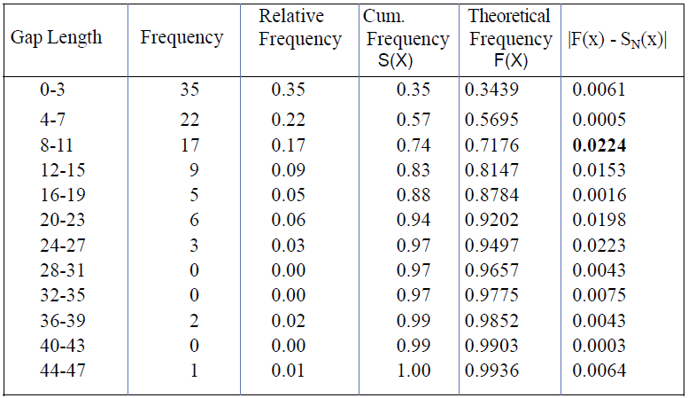
F(x) = 1-0.9^{x+1}

Example:
F(x) = 1-0.9^{x+1}
F(x) = 1-0.9³⁺¹
1-0.9⁴
1−0.6561=0.3439

Where x is upper boundary of gap length i.e. 3, 7, 11, 15 ……. 43, 47
Now, Calculate the value of D
D = max {F(x)-S_{N}(x)}
D = 0.0224
Now, Find the value of D_{α} at N=100 from K-S table of critical value
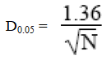
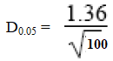
D_{0.05} = 0.136
Here, D < D_{0.05} hence null hypothesis is accepted
This shows that according to gap test given random numbers are independent.

Assignment:
- Based on the frequency with which gaps occur, analyze the digits below to test whether they are independent. Use α = 0.05.
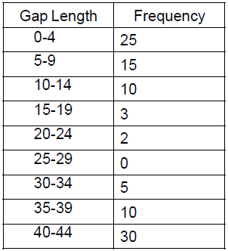
- Based on the frequency with which gaps occur, analyze the digits below to test whether they are independent. Use α = 0.2.
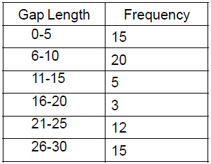

Poker Test:
The poker test for independence is based on the frequency with which certain digits are repeated in a series of numbers. This test not only tests for the randomness of the sequence of numbers, but also the digits comprising of each of the numbers.
The expected value of each of the combination of digits in a number is compared with the observed value by means of the chi-square test for independence. The acceptance is done if the observed value of chi- square sums for all the possible combinations of digits is less than the acceptable value for the given degree of freedom at the specified confidence interval.
- This test gets its name from a game of cards called poker
- This test not only tests the randomness of the sequence of numbers, but also the digits comprising of each number
- Every random number of five digits or every sequence of five digits is treated as poker hand.
The poker test uses the Chi-Square statistics to accept or reject the null hypothesis.
Algorithm for Poker Test:
Step 1: Define hypothesis for testing independence as:
H₀ : R_{i} ~ Independent
H₁ : R_{i} !~ Independent
Step 2: Generate frequency distribution for n combinations (as possible for n digit number) and apply Chi-Square test
Step 3: Compute test statistics as

Step 4: Determine for significant level α, X² _{α,n-1}
Step 5:
If X² < X² _{α,n-1}
Null hypothesis (H₀) is accepted that means random numbers are independence
Else
Null hypothesis (H₀) is rejected, that means random numbers are not independence

The poker test for 3-digit numbers
In 3-digit numbers there are only three possibilities, as follows:
- The individual numbers can all be different.
- The individual numbers can all be the same.
- There can be one pair of like digits.
The probability associated with each of these possibilities is given by the following
P (three different digits) = P (second different from the first) x P (third different from the first and second)
= (0.9) (0.8)
P (three different digits) = 0.72
P (three like digits) = P (second digit same as the first) x P (third digit same as the first)
= (0.1) (0.1)
P (three like digits) = 0.01
P (exactly one pair) = 1 – [P(three different digits)+ P(three like digits)]
= 1 – [0.72 + 0.01]
P (exactly one pair) = 0.27
Example: A sequence of 1000 three-digit numbers has been generated and an analysis indicates that 680 have three different digits, 289 contain exactly one pair of like digits, and 31 contain three like digits. Based on the poker test, are these numbers independent? Let α = 0.05. Test these numbers using poker test for three digits.

Solution:
Define hypothesis for testing independence as:
H₀ : R_{i} ~ Independent
H₁ : R_{i} !~ Independent
Now generate the frequency distribution table and apply chi-square test
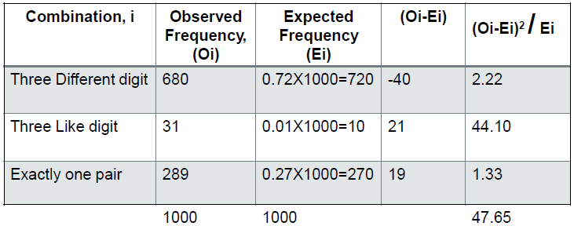
There are three conditions so, n=3
The test statistics

X² = 47.65
Then, the critical value of X²_{α, n-1} is
X²_{0.05, 3-1} = X²_{0.05, 2} = 5.99
Here, X² > X²_{0.05, 2} hence null hypothesis is rejected
This shows that according to Poker Test given random numbers are not independent.
Assignment:
- The sequence of three-digit numbers has been generated and an analysis indicates that 300 have three different digits, 500 contain exactly one pair of like digits, and 200 contain three like digits. Based on the poker test, are these numbers independent? Let α = 0.05. Test these numbers using poker test for three digits.

Poker test for 4-digit numbers:
When grouping digits into sequences of 4 for the poker test, the hand types change slightly compared to grouping by 5 digits. The typical hand types for 4-digit sequences include:
- All different digits (e.g., 1234)
- One pair (e.g., 1123)
- Two pairs (e.g., 1122)
- Three of a kind (e.g., 1112)
- Four of a kind (e.g., 1111)

The probability associated with each of these possibilities is given by the following
P (four different digits) = 4c4 x 10/10 x 9/10 x 8/10 x 7/10
P (four different digits) = 0.504
P (one pair) = 4c2 x10/10x1/10x9/10x8/10
P (one pair) = 0.432
P (two pair) = 4c2/2 x 10/10 x 1/10 x 9/10 x 1/10
P (two pair) = 0.027
P (three digits of a kind) = 4c3 x 10/10 x 1/10 x 1/10 x 9/10
P (three digits of a kind) = 0.036
P (four digits of a kind) = 4c4 x 10/10 x 1/10 x 1/10 x 1/10
P (four digits of a kind) = 0.001
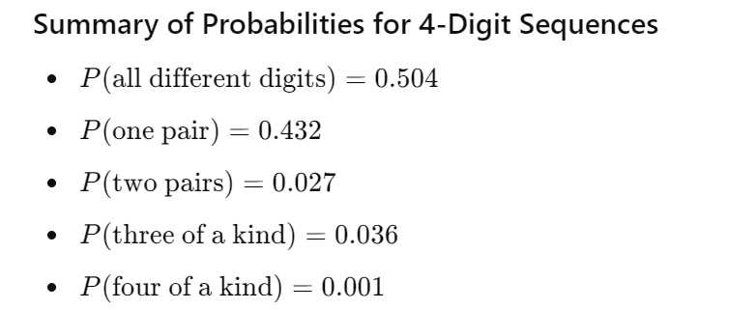
Example: A sequence of 1000 four digit numbers has been generated and an analysis indicates the following combinations and frequencies.
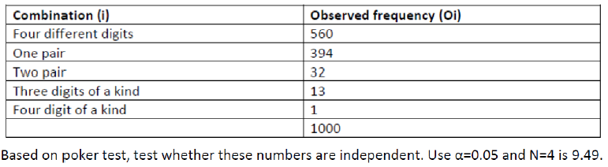

Solution:
Define hypothesis for testing independence as:
H₀ : R_{i} ~ Independent
H₁ : R_{i} !~ Independent
Now generate the frequency distribution table and apply chi-square test
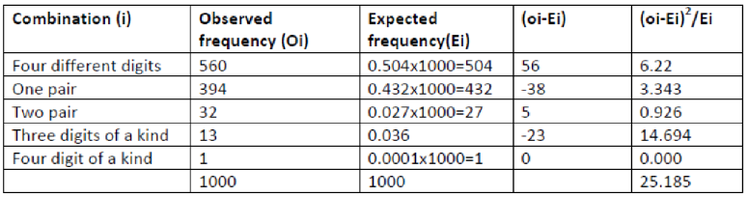
There are five conditions so, n=5
The test statistics

X² = 25.185
Then, the critical value of X²_{α, n-1} is
X²_{0.05, 4-1} = X²_{0.05, 3} = 9.49
Here, X² > X²_{0.05, 3} hence null hypothesis is rejected
This shows that according to Poker Test given random numbers are not independent.

Assignment:
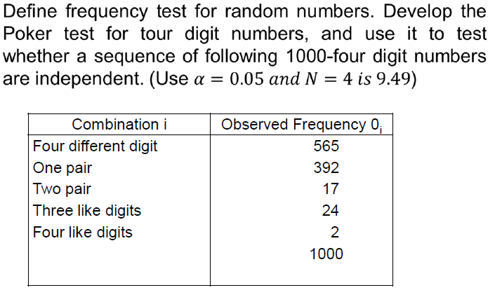

General Rules for the Poker Test For group into sequences of 5
- Group Size: Typically, the digits are grouped into sequences of 5. For example, in a sequence of random numbers, you might group every set of 5 digits together to form a "hand."
- Hand Types: Different types of hands are considered, similar to poker hands. Common types include:
- All different digits (e.g., 12345)
- One pair (e.g., 11234)
- Two pairs (e.g., 11223)
- Three of a kind (e.g., 11123)
- Full house (e.g., 11122)
- Four of a kind (e.g., 11112)
- Five of a Kind: (e.g., 11111).

- Number of Digits: There is no strict rule about the total number of digits to be taken for the test, but it should be large enough to provide a meaningful statistical sample. Commonly, thousands of digits are used to ensure the reliability of the test results.

The probability associated with each of these possibilities is given by the following
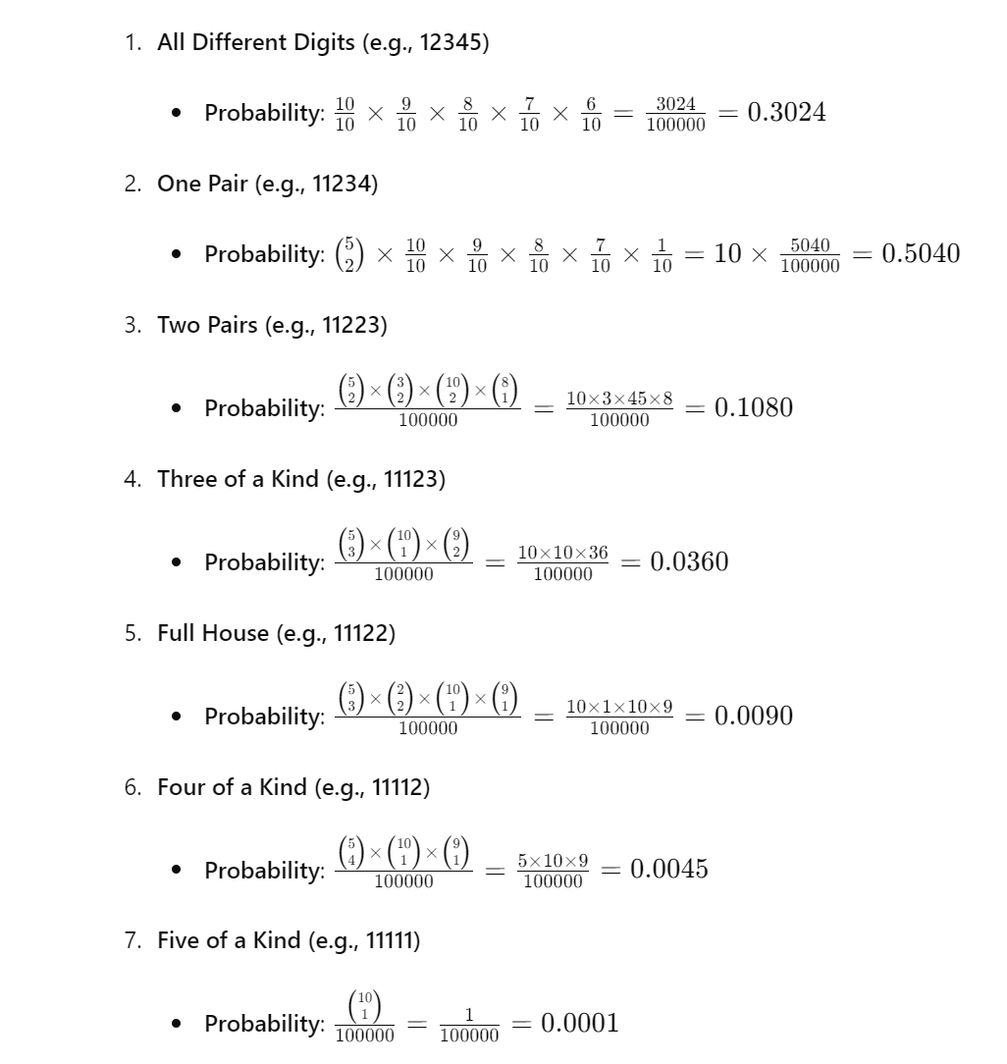
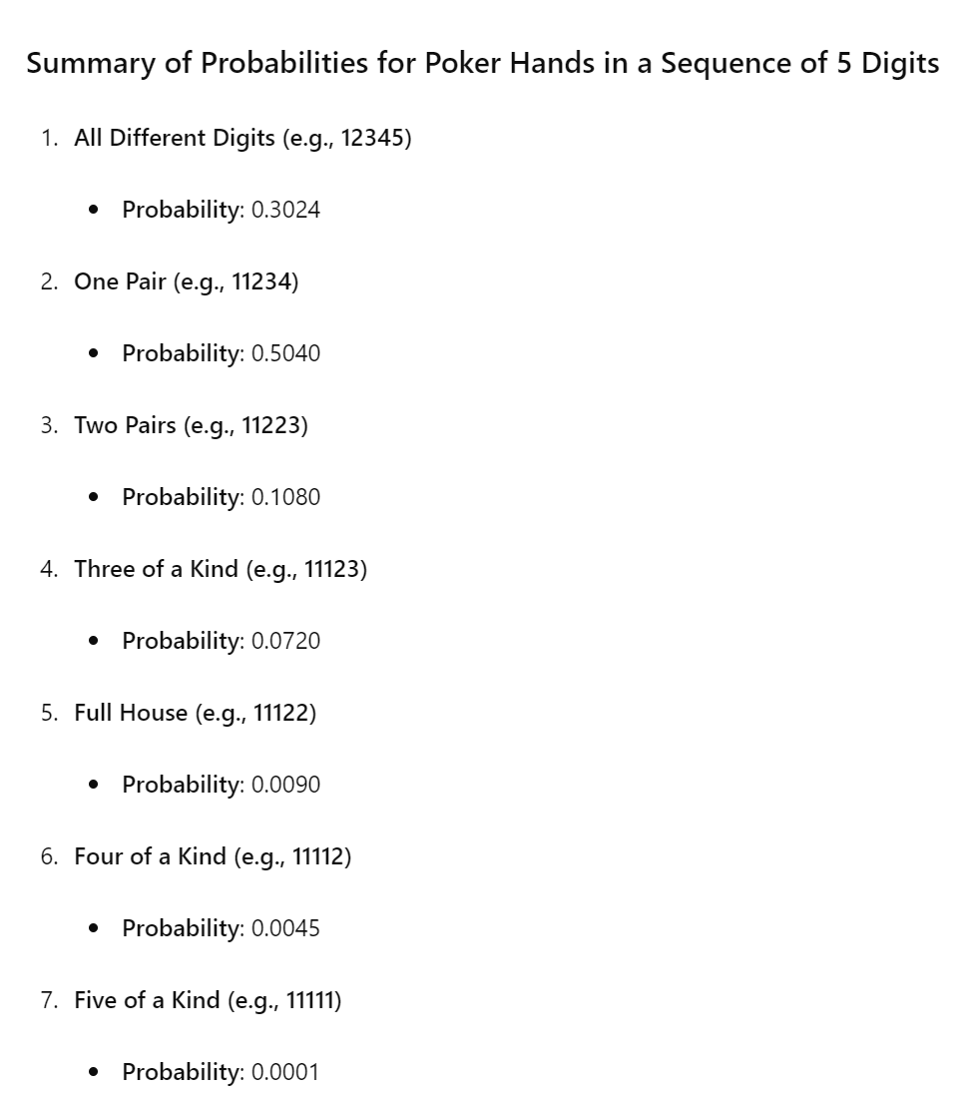

Assignment:

Short Questions
- What do you mean by Pseudo random numbers?
- Explain non-uniform random number generation.
- Use the linear congruential method to generate a sequence of three two-digit random integers. Let X0=29, a=9, c=49 and m=100.
- Use the mixed congruential method to generate a sequence of three two digit random numbers with Xo=37, a=7, c=29 and m=100.
- Explain the congruence method of generating random numbers.

Long Questions
- What is the main objective of gap test? Explain gap test algorithm with example.
- Explain the process of Poker test for four digit numbers.
- What do you mean by uniformity test? Explain the poker test with example.

End of unit-5

